

Subcontractors – Insurance Requirements

Our insurance carrier has mandated that our subcontractors provide us with a certificate of insurance that meets the following criteria:

- General Liability:
Commercial Liability Policy
Each Occurrence minimum limit of $1,000,000

- Commercial Automobile Liability:
Combined Single limit of $1,000,000

- Workers’ Compensation & Employers’ Liability:
Included

- Waiver of Subrogation in favor of INTERVEST Construction Corporation and all its subsidiaries in regards to General Liability, Automobile Liability, and Workers’ Compensation Coverage.

- Additional Insured Endorsement naming INTERVEST Construction Corporation and all its subsidiaries as additional insured in regards to General Liability and Automobile Liability on a Primary and Non-Contributory basis.

- 30 days written notice of cancellation

We need your compliance with the above insurance requirements before any work begins. If you have any questions regarding the above, please give us a call at (601) 709-6000 ext. 32 or (601) 946-0060.

Thank you for your understanding and assistance.

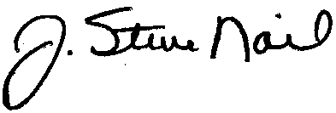

J. Steve Nail
President



P.O. Box 2118 * Madison, MS 39130-2118 * Calumet Professional Park * 7538 Old Canton Road * Madison, MS 39110-8967
P.O. Box 610 * Decatur, MS 39327 (601) 709-6000 * Fax (601) 709-2350 P.O. Box 185 * Holly Springs, NC 27540-0185

